Trigonometry – Practical Brief
An architect wants to design a ramp that could increase accessibility to all schools. He is tasked with designing three different ramps, being mindful of regulations when it comes to health and safety procedures when designing ramps. Schools can then decide which ramp best suits the needs of their schools. Design one ramp for each of the following scenarios:

- Connects a single step of 22cm to the ground.
- Connects three steps of a height of 66cm to the ground.
- Connects seven steps of a height of 1.4m to the ground.
Diagrams should be drawn to represent each design.
Students can push the boundary as much as they like, using costing, diagrams and materials. Sources should be given for any research carried out.

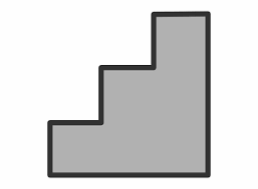

Potential Headings:
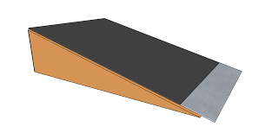
Background Research
Diagrams
Mathematical Concepts
Additional Workings:
Conclusions:
References:

