Fill in the table below to two decimal places.
Label the diagram with respect to the angle (A) given | Sin(A) | $$\frac{O}{H}$$ | Cos(A) | $$\frac{A}{H}$$ | Tan(A) | $$\frac{O}{A}$$
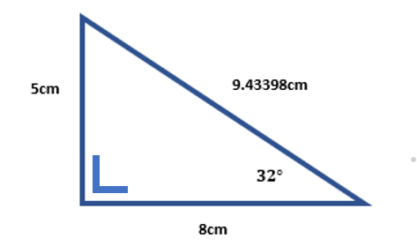
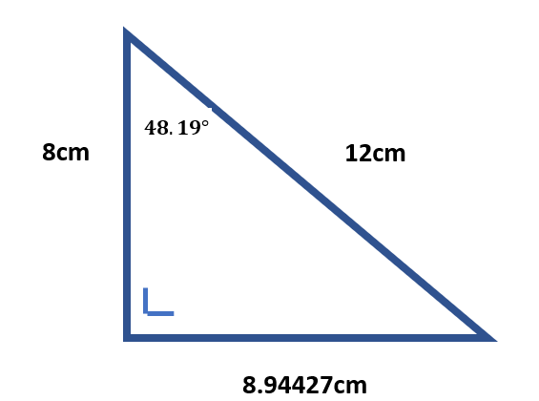
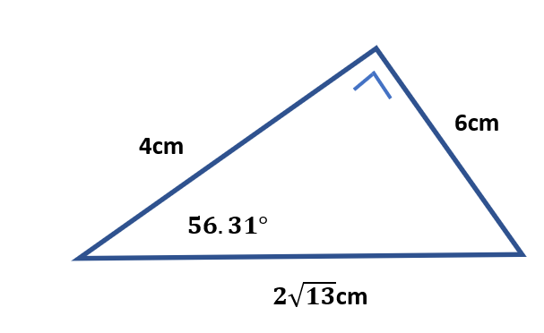
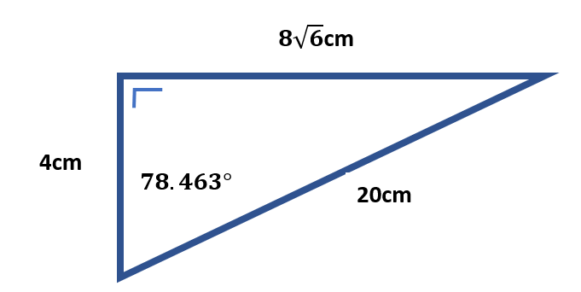
Summarise the rules we have learned to help us with future problems:

