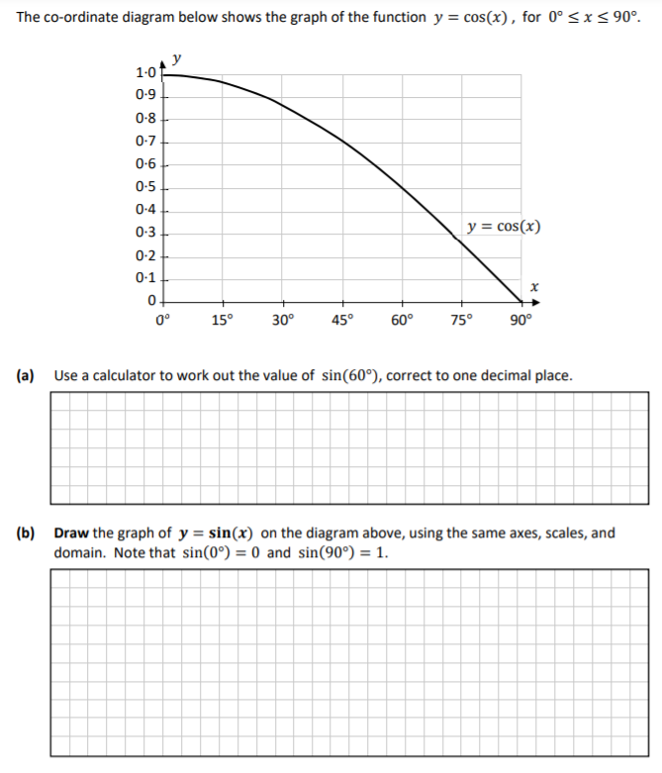

a
- Estimate the value of $Cos(60)$ using your graph.

- Use a calculator to work out the value of $cos⁡(60)$, correct to one decimal place.

- Complete the table below, correct to one decimal place.
$$x$$ | 0 | 15 | 30 | 45 | 60 | 75 | 90
$$sin⁡(x)$$

- Hence, draw the graph of $y=sin⁡(x)$ on the diagram above, using the same axis and scale.
- Use your graph to find the value of x, for which $Sin(x)=0.6$.

Extension:
Both functions have the same outputs for different values of x. What relationship is there between these x-values?

