**Create different sized triangles using the ladder (toothpick) and the wall.**

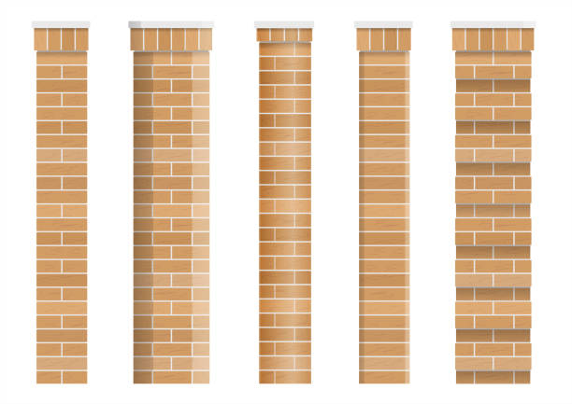

Describe the triangle created (the angle and the sides at the wall/ground).



Describe the triangle created (the angle and the sides at the wall/ground).



Describe the triangle created (the angle and the sides at the wall/ground).



Describe the triangle created (the angle and the sides at the wall/ground).

**Measure, using a ruler, the lengths of the wall and ground for a variety of angles.**

Acute angle of 60 degrees at A (measured with protractor). B must be 30 degrees.

Wall =

Ground =

Acute angle of 30 degrees at A (measured with protractor). B must be 60 degrees.

Wall =

Ground =

Acute angle of 75 degrees at A (measured with protractor). B must be 15 degrees.

Wall =

Ground =