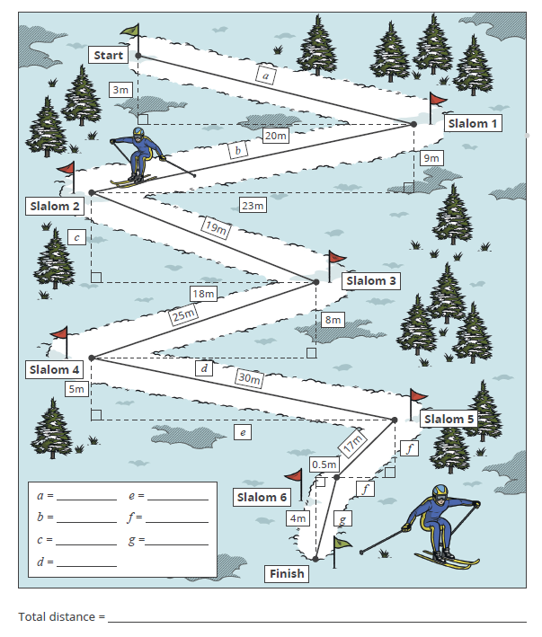
Below is the plan view of the alpine ski slope (not drawn to scale). Calculate the missing length on each slalom, giving your answers correct to 3 significant figures. What is the total distance covered by the skier, assuming they take the shortest route possible between each slalom?

Extension:
Construct a scale diagram of the ski slope, using a scale of 1cm = 2m.

