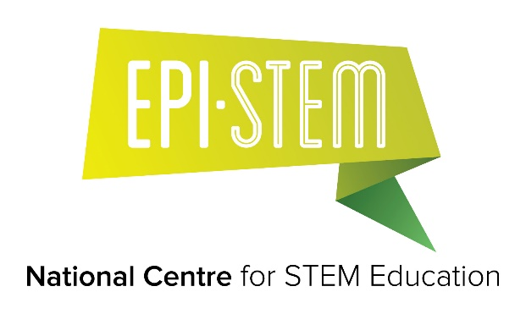
EPI*STEM NEWS ITEM 11 February 2022

Applications are invited for the following position [for more information visit the University of Limerick Human Resources website: www.ul.ie/hrvacancies/]

Faculty of Education & Health Sciences

School of Education/EPI*STEM National Centre for STEM Education

Post Doctoral Researcher in Mathematics Education – Specific Purpose Contract

Salary Scale: €39,132 - €50,529 p.a. pro rata (maximum starting salary of €39,686 p.a. pro rata)

Informal enquiries regarding the post may be directed to:
Dr Geraldine Mooney Simmie
Director of EPI*STEM
School of Education
University of Limerick
Email: Geraldine.Mooney.Simmie@ul.ie

The closing date for receipt of applications is Tuesday, 1st March 2022.

Applications must be completed online before 12 noon, Irish Standard Time on the closing date.

